**Getting Started**

**Software Versions**

This project uses the following software versions:

|  |  |
| --- | --- |
| **Software** | **Version** |
| Solr | 8.4.0 |
| Sitecore.PowerShell.Extensions | 6.3 |
| Sitecore Experience Accelerator | 10.2.0 rev. 04247 |
| Sitecore ManagementServices | 4.1.0 rev. 00492 |
| Visual Studio / MSBuild | 2019 / 16.x |

**Locations and settings**

This project assumes the following settings:

|  |  |
| --- | --- |
| **Setting** | **Value** |
| Source location | C:\projects\centralsitecoresxa\ |
| Website location | C:\inetpub\wwwroot\centralgardensc.dev.local\ |
| SOLR Location | C:\Solr\solr101solr-8.4.0 |
| SOLR Windows Service Name | solr101solr-8.4.0 |

**Prerequisites**

1. Download the Sitecore from the below URL :

<https://dev.sitecore.net/Downloads/Sitecore_Experience_Platform/102/Sitecore_Experience_Platform_102.aspx>

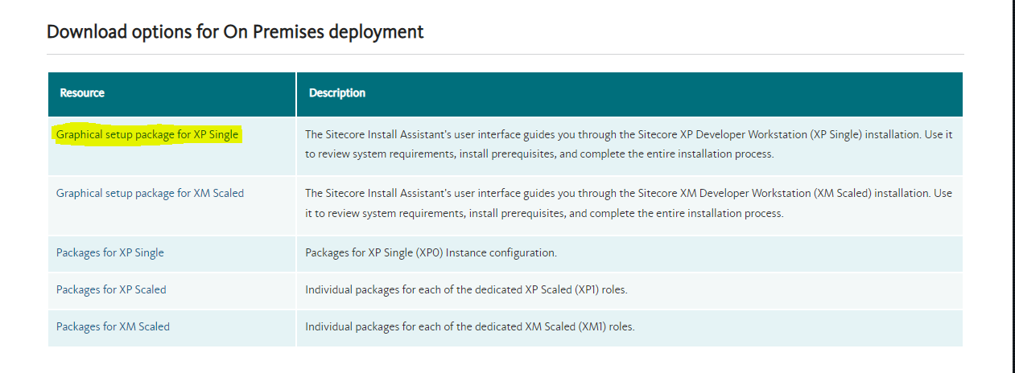

1. After downloading, extract the downloaded zip folder in a newly created folder, like C:\Sitecore-10.2.0
2. Now open Powershell in Administrator mode and navigate to the folder where you have extracted the zip folder(In this case C:\ Sitecore-10.2.0) using command : cd C:\ Sitecore-10.2.0
3. Now run command : Install-SitecoreConfiguration –Path “.\Prerequisites.json”

This will download and install all the prerequisites required for installing sitecore.

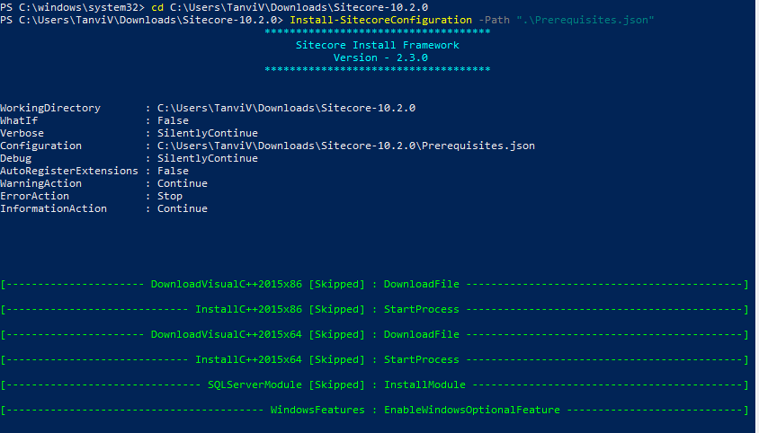

1. Open this Solr-SingleDeveloper.json file in your sitecore setup folder.
2. Update simple parameters like what version of Solr you want(in our case 8.4.0), what port number you would like to associate it with and what should be default install location(Create a folder named Solr in C drive and specify that as the path).
3. Run this SIF command:

Install-SitecoreConfiguration ".\Solr-SingleDeveloper.json"

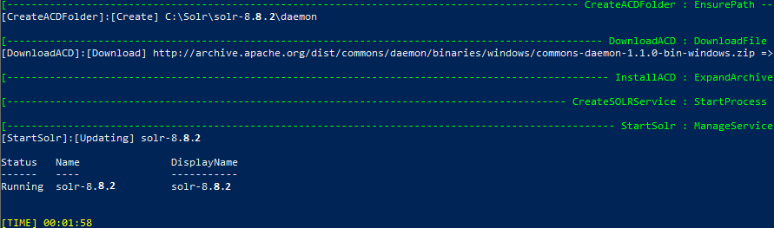

1. After downloading, check on the url as mentioned in below screenshot.

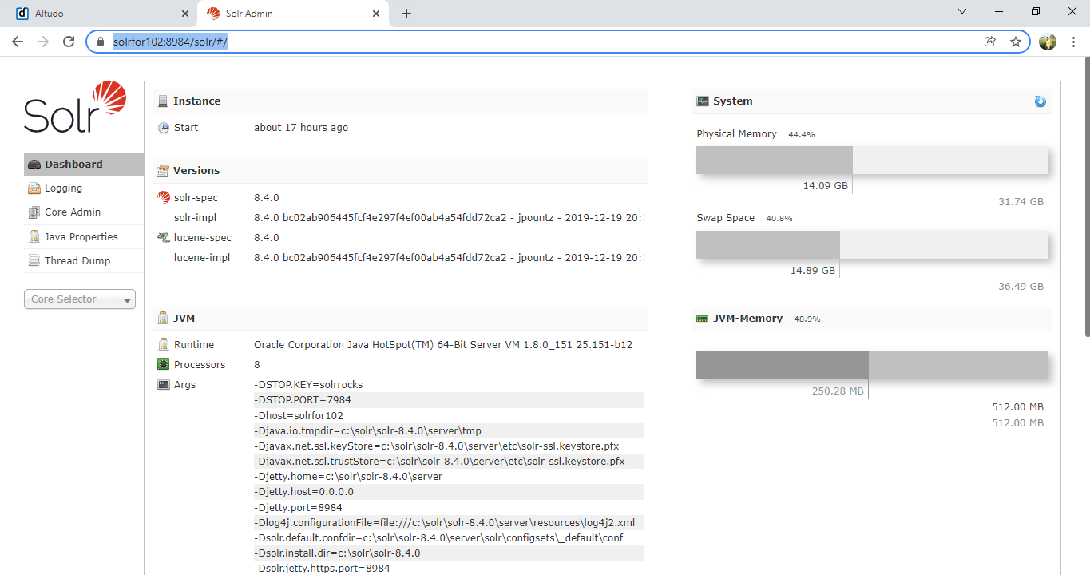

**Installation**

**1. Installing Sitecore**

1. Open SSMS 18 in ‘Run as administrator’ mode and copy the server name.

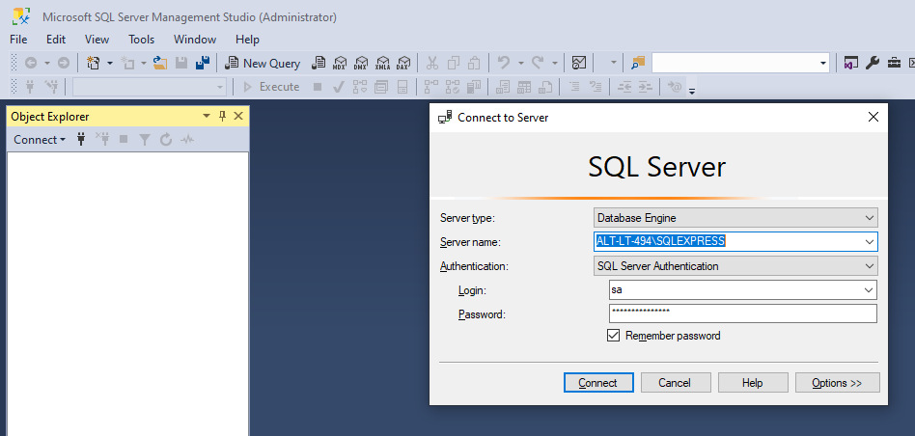

1. Go to the site core setup and follow the steps-

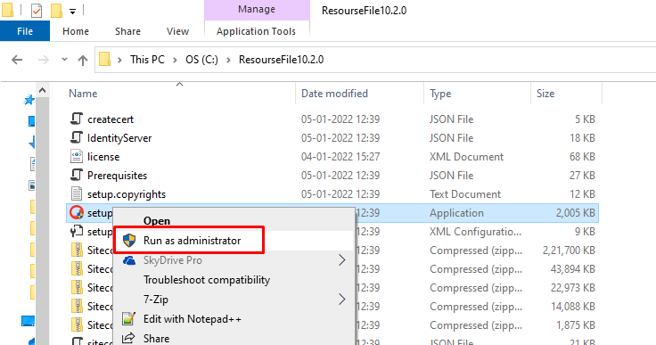

As ‘prerequisites’ are already installed then skip this step-

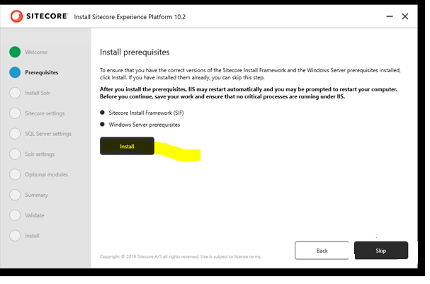

Skip the below step also-

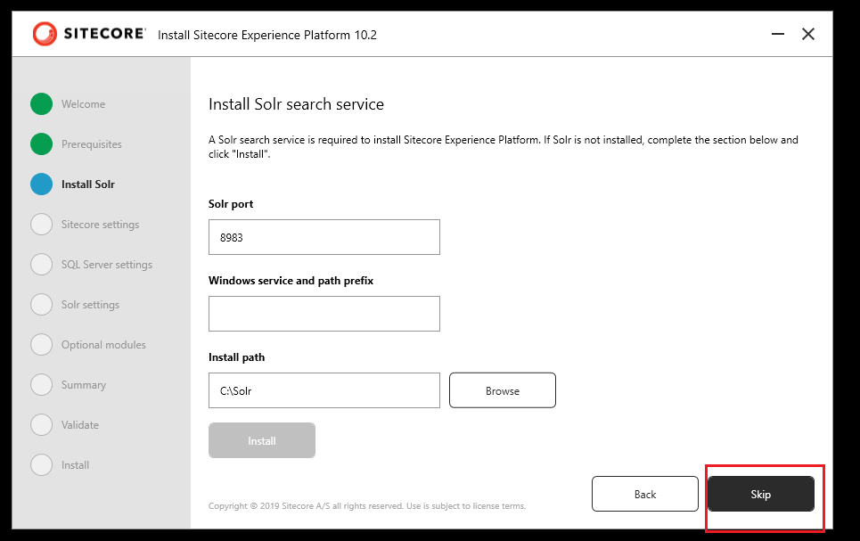

Fill the fields with **centralgarden**, **b** and **select license** values respectively and click next button-

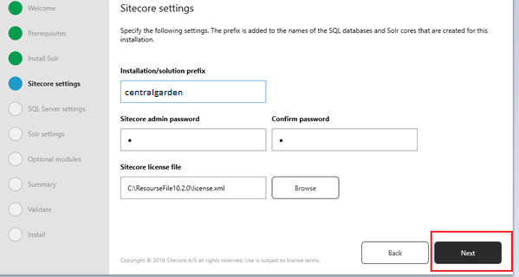

Enter the SSMS server name, user name and password and click Next Button.

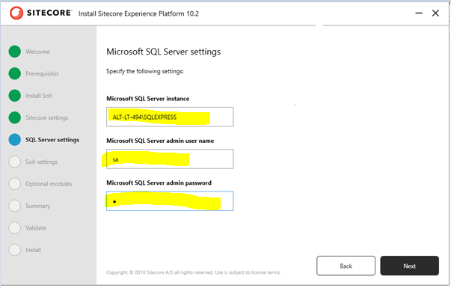

Enter the solr service URL, Solr file location and service name and click Next.

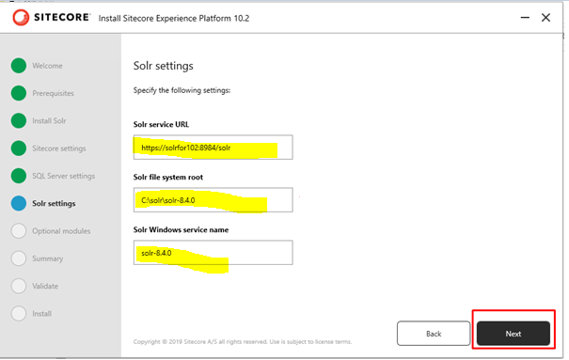

Select Sitecore Experience Accelerator option and click Next.

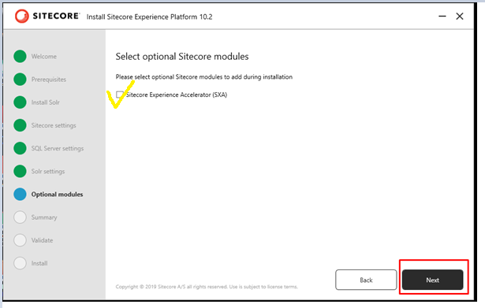

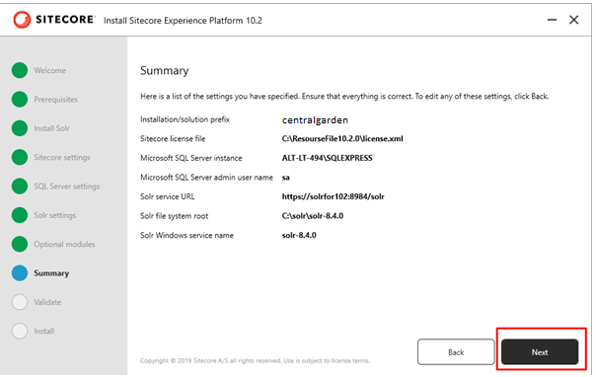

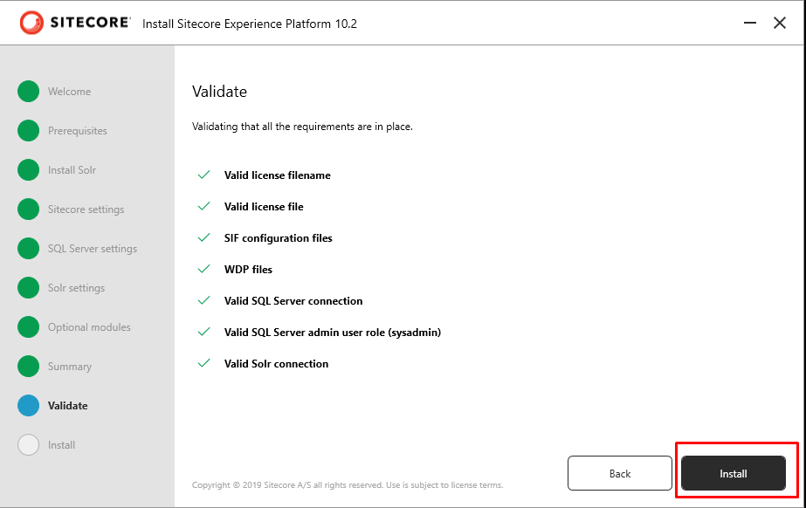

*Sitecore will be installed. If you face any issue connect with Mentor or drop message on group chat without waiting to anyone.*

**2. Build and Deploy Habitat**

1. Clone the Git Repository from bit bucket url mentioned below to your source location. <https://bitbucket.org/centralgardenpet/centralsitecoresxa/src/master/>

2. Run following commands in sequence

* npm init to create package.json
* npm install gulp@3.9.1 --save-dev
* npm install gulp-msbuild
* npm install gulp-debug
* npm install gulp-foreach
* npm install run-sequence

3. Open Task Runner Explorer and refresh to see task updated.

4. If you see "ReferenceError: Premordials not defined" after running Gulp -

* Create a file at root level named npm-shrinkwrap.json
* Copy and paste following lines in that file:

{

"dependencies": {

"graceful-fs": {

"version": "4.2.2"

}

}

}

* Run npm install again

5. Make sure identityserver config file is deployed

Location :- "~\identityserver\Config\Sitecore.IdentityServer.CGP.xml" to the location "<wwwroot>\.<identityserver>\Config"

6. Make sure CLI config file is deployed to CM role.

Location :- "~/src\Project\Website\code\App_Config\Environment\Project\Project.Owin.CGP_CLI.config"

**Serialization setup**

1. Download the Asp .Net Core from below link. [Download .NET Core 3.1 (Linux, macOS, and Windows) (microsoft.com)](https://dotnet.microsoft.com/en-us/download/dotnet/3.1)
2. Install the Asp.Net Core installer on your machine.
3. Once the installation is done. Open the Powershell window in Admin mode. Go to solution folder location. Run the below two commands:
   1. dotnet new tool-manifest
   2. <https://sitecore.myget.org/F/sc-packages/api/v3/index.json>
   3. Screenshot for reference:

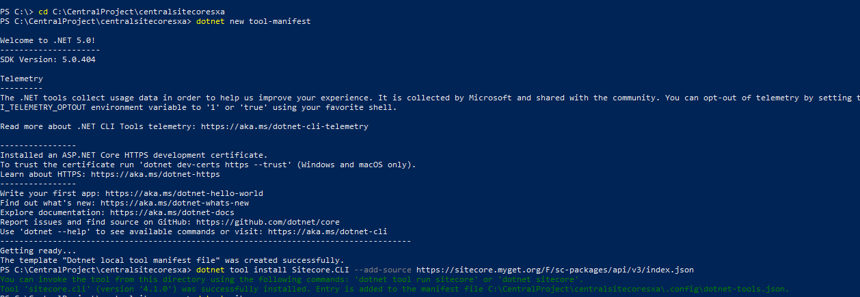

1. Download Sitecore Management Services CLI Package from below link: <https://dev.sitecore.net/Downloads/Sitecore_CLI/4x/Sitecore_CLI_401.aspx> and Install this package in your local sitecore instance. For eg: <https://centralgardensc.dev.local/sitecore>
2. Check the Identity Server and sitecore url are running and you are able to login, for the sitecore setup done locally. For eg:
   1. Identity Server : <https://centralgardenidentityserver.dev.local> . Open this url and check you are successfully able to login.

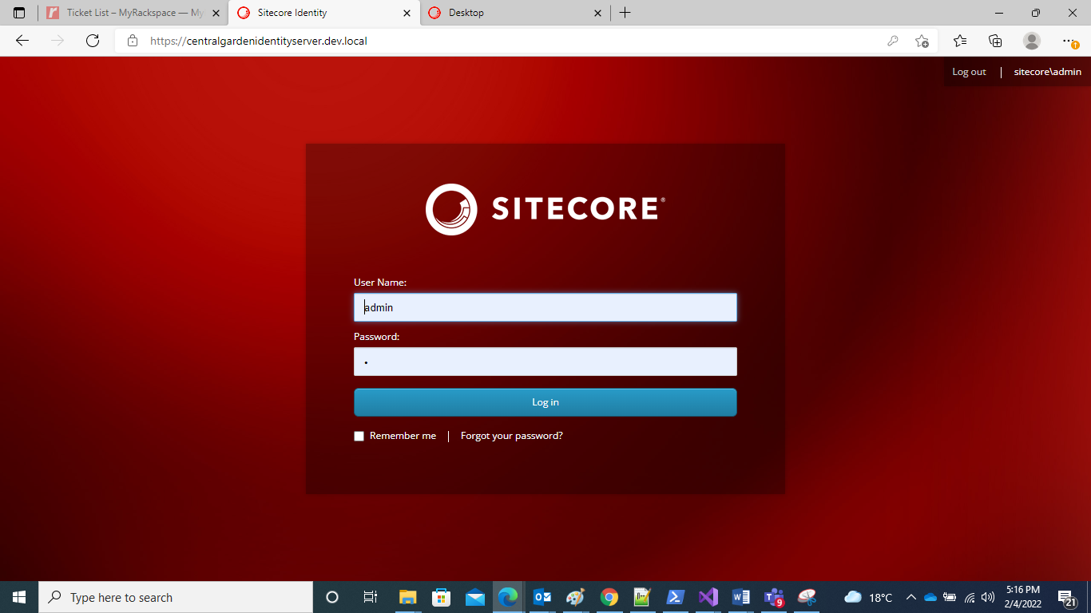

* 1. Sitecore login : <https://centralgardenidentityserver.dev.local> . Open this url and check you are successfully able to login.

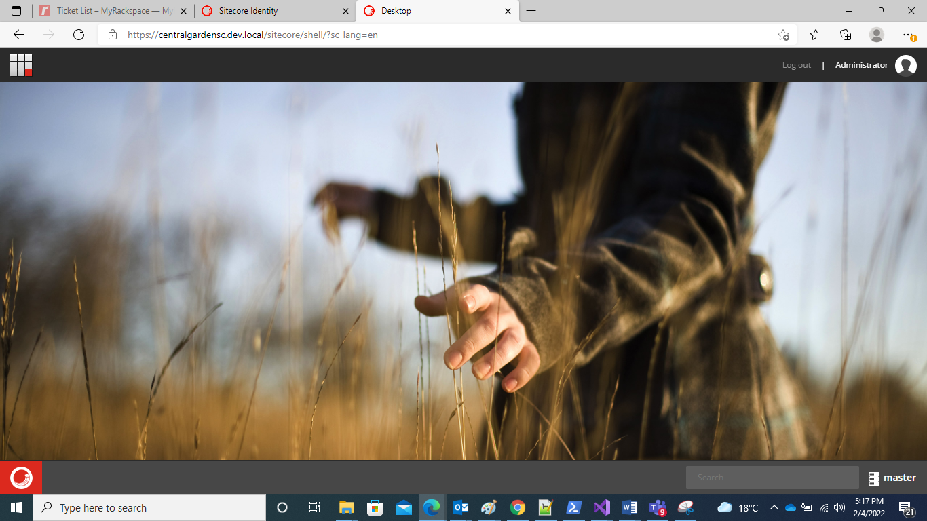

* 1. Close both the instance open in step a and b.

1. Run the below command in PowerShell window open in Admin mode.
   1. Replace the identity server and s curl wrt to url for sitecore instance setup on your local as you just tested in above step in below command before running.

dotnet sitecore login --authority [https://centralgardenidentityserver.dev.local](https://centralgardenidentityserver.dev.local/) --cm [https://centralgardensc.dev.local](https://centralgardensc.dev.local/) --allow-write true

1. Once the command is successfully run it will open the Sitecore in browser, once open login and then click on Yes allow button. Once successfully done. Please close the window.

Now our setup is done.

**Git and serialization commands**

Once you are done with the setup, to start with development go to the below Bitbucket url to create your own branch

<https://bitbucket.org/centralgardenpet/centralsitecoresxa/branches/>

1. Click on the Create Branch button

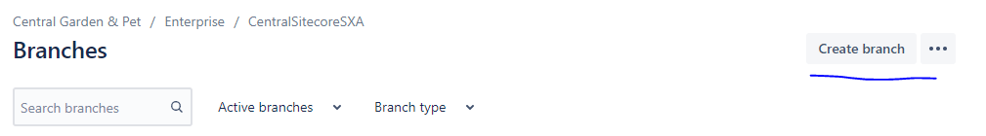

1. The branch is always created fom “Master” branch. The branch name is given in the below syntax

“Feature/your-branch-name”

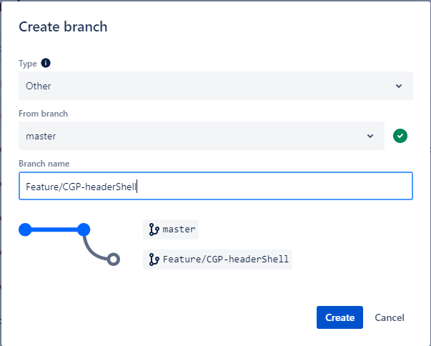

1. After filing the details click on Create button. Your branch will be created.
2. Open Powershell window and navigate to source location of your project using command : *cd C:\Projects\centralsitecoresxa*
3. Execute the following git commands

* *git fetch -* This will download all the content from remote repository.
* *git checkout Feature/your-branch-name –* To check into the branch that you created.
* *git fetch* - To download all the changes to your branch
* *git merge origin/develop* - To merge all the changes from develop branch to your local branch

1. After executing these commands, all the changes will be added to your branch. Sync all the changes.
2. Now execute the below serialization command to push the changes to sitecore : *dotnet sitecore ser push –publish*
3. Now your branch and sitecore is updated.
4. After you are done with development, again execute the git commands mentioned above so as to avoid merge conflicts.
5. Now execute this serialization command to bring your sitecore changes to git : *dotnet sitecore ser pull*
6. Also run this this command to remove any orphaned items/folders which can later cause error in serialization : *dotnet sitecore ser validate --fix*
7. Open your project in Visual Studio and verify if all the changes have been pulled.
8. Stage all the changes and commit them to your branch.
9. Now execute git command, *git push,* to push your changes to your branch.
10. Now go to the above url to raise pull request for your branch :

[*https://bitbucket.org/centralgardenpet/centralsitecoresxa/pull-requests/*](https://bitbucket.org/centralgardenpet/centralsitecoresxa/pull-requests/)

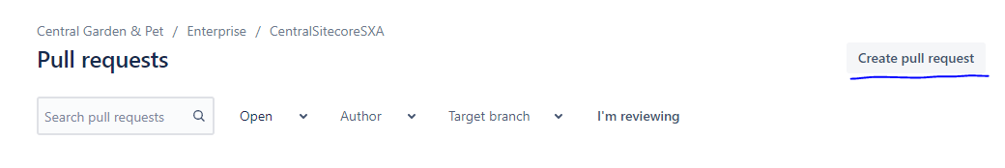

1. When you click on Create pull request, the below page will open.

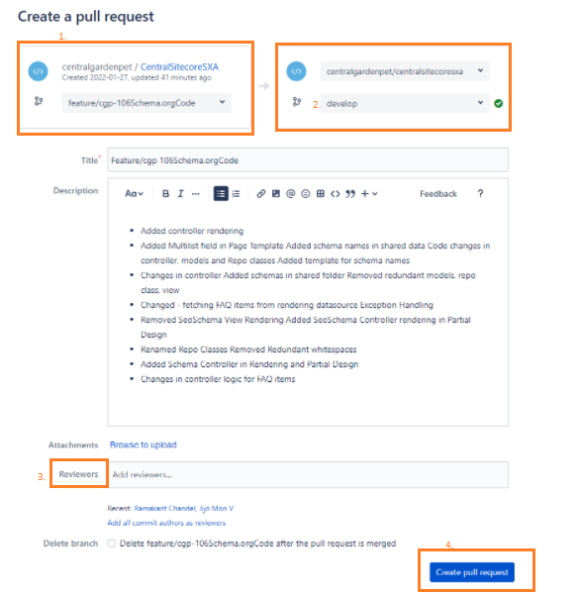

* 1. Select your branch name
  2. Select *Develop* as all the changes are first merged to develop branch.

Also add the title and description for the reviewer to understand what all has been modified in your PR.

* 1. Add reviewers.
  2. Click on Create pull request button.